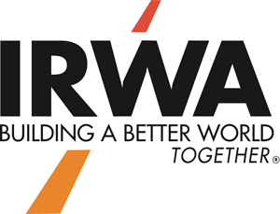

Name and Title of one of the following: IRWA Chapter/Region Officer or Chapter Professional Development Committee Chair or Chapter Education Committee Chair

## Name

# This certifies that

## Attended the

## And has earned hours of IRWA approved re-certification credits.

## On (dates)

# **Certificate of Attendance**